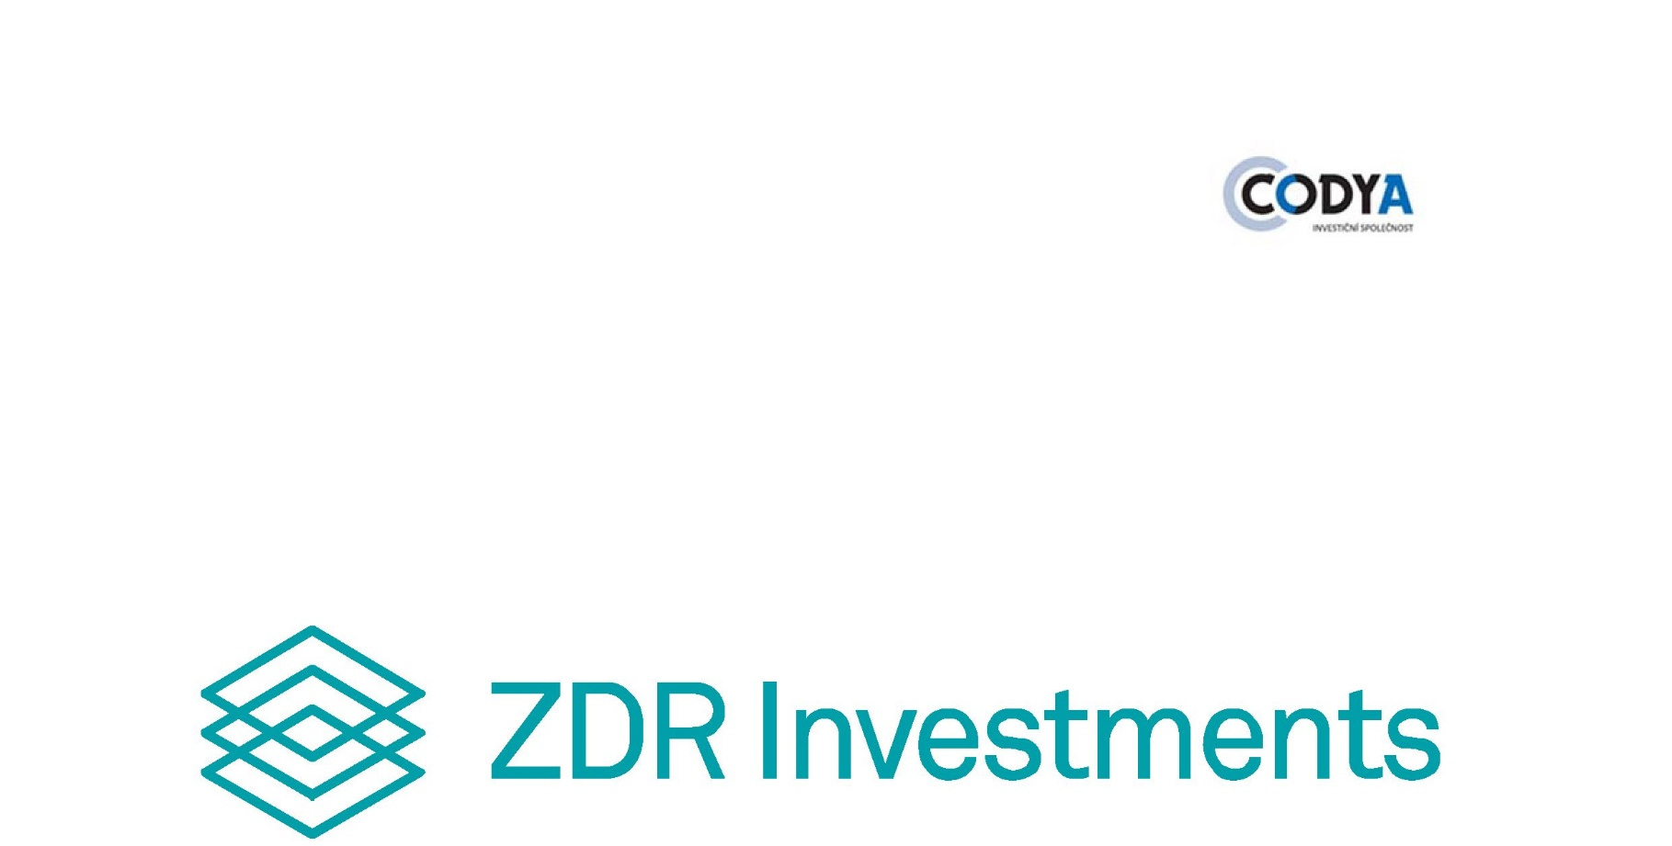

ANNUAL REPORT
FOR THE YEAR ENDING 31st DECEMBER 2023

STATEMENT OF THE STATUTORY BODY
This Annual Report, prepared with due care, gives, to the best of my knowledge, a true and fair view of ZDR Investments SICAV a.s., its financial position, business activities and results of operations for the year ending 31st December 2023, of its prospects for future development, business activity and results of operations, and no facts have been omitted which might alter the meaning of this report.
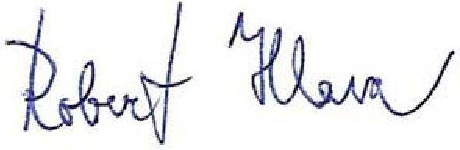
In Brno, on 30 April 2024

ZDR Investments SICAV a.s.
Ing. Robert Hlava
Authorised Agent of the Sole Member of the Board of Trustees
CODYA Investment Company, a.s.



Independent Auditor's Report on
ZDR Investments SICAV
a.s.
for the audited period
of 1 January 2023 to 31 December 2023

Accounting unit identification
Company: ZDR Investments SICAV a.s.
Company ID: 064 21 091
Headquarters: Jungmannova 750/34, 110 00 Prague
Legal status: Joint stock company
Commercial Register Section and File number: B 22826, Registration Court in Prague

The report is addressed to the company shareholders
Auditor's Statement
The subject of the present audit comprised the attached Financial Statements of ZDR Investments SICAV a.s. (the "Company"), prepared in accordance with Czech accounting regulations, and including Balance Sheet as of 31 December 2023, Profit and Loss Report, Statement of Changes in Equity, and Statement of Off-Balance Sheet Items for the year ending 31 December 2023, and Notes to Financial Statements, with a description of significant accounting policies used and other explanatory information. Details of ZDR Investments SICAV a.s. are set out in Note 1 to these Financial Statements.
In our opinion, the Financial Statements give a true and fair view of the assets and liabilities of ZDR Investments SICAV a.s. as of 31 December 2023 and of the costs and income and result of its operations and off-balance sheet items for the year ended 31 December 2023 in accordance with Czech accounting regulations.
Basis for Auditor´s Statement
The audit was conducted in accordance with the Act on Auditors and the standards of the Chamber of Auditors of the Czech Republic for auditing, which are the International Standards on Auditing (ISA), supplemented and modified by related application clauses, where appropriate. Our responsibilities under these regulations are described in more detail in the part titled Auditor's Responsibilities for Audit of Financial Statements. In accordance with the Act on Auditors and the Code of Ethics adopted by the Chamber of Auditors of the Czech Republic, the auditors are independent of the Company and have fulfilled other ethical obligations arising from these regulations. The auditors believe that the evidence gathered provides a sufficient and appropriate basis for the present Auditor´s Statement.
Other Information in Annual Report
In accordance with Section 2(b) of the Auditors Act, Other Information means information contained in the Annual Report other than the financial statements and the present Auditor's Statement. Other Information is the responsibility of the Company's Board of Trustees.
The Auditor´s Statement on the Financial Statements is not applicable to Other Information. Nevertheless, part of the auditor´s responsibilities in connection with the audit of Financial Statements is to read Other Information and assess whether there is any material inconsistency between Other Information and the Financial Statements being audited or the knowledge of the entity obtained in the course of the audit or whether Other Information otherwise appears to contain any material misstatement. The auditors also assess whether Other Information has been prepared in all material respects in accordance with the relevant legislation. This assessment means finding out whether Other Information complies with the legal requirements on the formality and process of Other Information preparation in the context of materiality, i.e. whether any failure to comply with these requirements would be likely to affect the judgement made on the basis of Other Information.
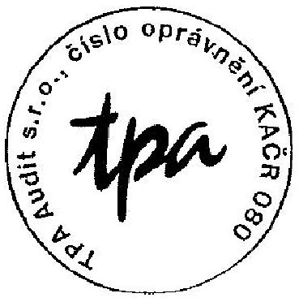
On the basis of the procedures carried out, to the extent that the auditors are able to judge, it is hereby stated that
• other Information that describes the facts that are also presented in the related Financial Statements is consistent in all material respects with the Financial Statements; and
• other Information has been prepared in accordance with the applicable legislation.
The auditors are also required to state whether, based on their knowledge and understanding of the Company obtained in the course of the audit, the mentioned Other Information is free from any material misstatement. As part of these procedures, no material misstatements were identified in Other Information received.

Responsibility of the Board of Trustees for Financial Statements
The Board of Trustees is responsible for the preparation of Financial Statements that give a true and fair view in accordance with Czech accounting regulations and for such internal controls as it determines necessary to enable the preparation of Financial Statements that are free from material misstatements, whether due to fraud or error.
In preparing the Financial Statements, the Board of Trustees of the Company is required to assess the Company's ability to continue as a going concern and, if applicable, to describe in the notes to the financial statements the matters relating to its going concern and the application of the going concern assumption in preparing the Financial Statements, except where the Board of Trustees plans to dissolve the Company or to wind up its activity or has no realistic alternative but to do so.
Auditor's Responsibility for the Audit of Financial Statements
The audit´s objective is to obtain reasonable assurance about whether the Financial Statements taken as a whole are free from any material misstatement, whether due to fraud or error, and to issue Auditor's Report that includes Auditor´s Statement. A reasonable degree of assurance is a high degree of assurance, but it is not a guarantee that an audit performed in accordance with the above provisions will, in all cases, detect any material misstatement that may exist in the audited Financial Statements. Irregularities may arise from fraud or error and are considered material if they can reasonably be expected, individually or in the aggregate, to affect the economic decisions that users may make.
In conducting an audit in accordance with the above regulations, it is the auditors´ responsibility to exercise professional judgement and maintain professional scepticism throughout the audit. Furthermore, the auditors are obliged to:
• Identify and evaluate the risks of material misstatements in the Financial Statements, whether due to fraud or error, design and perform audit procedures to address those risks, and obtain sufficient appropriate audit evidence to provide a basis for Auditor´s Statement. The risk of not detecting a material misstatement due to fraud is greater than the risk of not detecting a material misstatement due to error because fraud may involve collusion, forgery, deliberate omissions, misrepresentations or circumvention of internal controls.
• Obtain an understanding of the Company's internal controls relevant to the audit in order to design audit procedures that are appropriate to the existing circumstances, but not for the purpose of expressing an opinion on the effectiveness of the Company's internal control system.
• Assess the appropriateness of the accounting policies used, the reasonableness of the accounting estimates made and the information provided by the Board of Trustees in this regard in the Notes to Financial Statements.
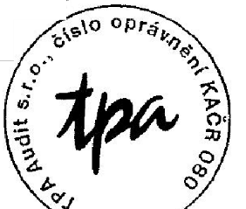
• Assess the appropriateness of the Board's use of the going concern basis in preparing the Financial Statements and whether, in light of the evidence gathered, there is any material uncertainty arising from events or conditions that may cast significant doubt on the Company's ability to continue its existence as a going concern. If the auditors conclude that such a material uncertainty exists, it is their responsibility to draw attention in Auditor´s Report to the information provided in the Notes to Financial Statements in this regard and, if that information is not sufficient, to issue a modified Auditor´s Statement. The auditors´ conclusions regarding the Company's ability to continue as a going concern are based on the evidence obtained up to the Auditor´s Report date. However, future events or conditions may cause the Company to lose its ability of continued existence.

• Evaluate the overall presentation, structure and content of the Financial Statements, including the Notes, and whether the Financial Statements present the underlying transactions and events in a manner that results in their fair presentation.
The auditors´ responsibility is to inform the Board of Trustees of, among other things, the planned scope and timing of the audit and the significant findings made during the audit, including any identified material weaknesses in the internal control system.
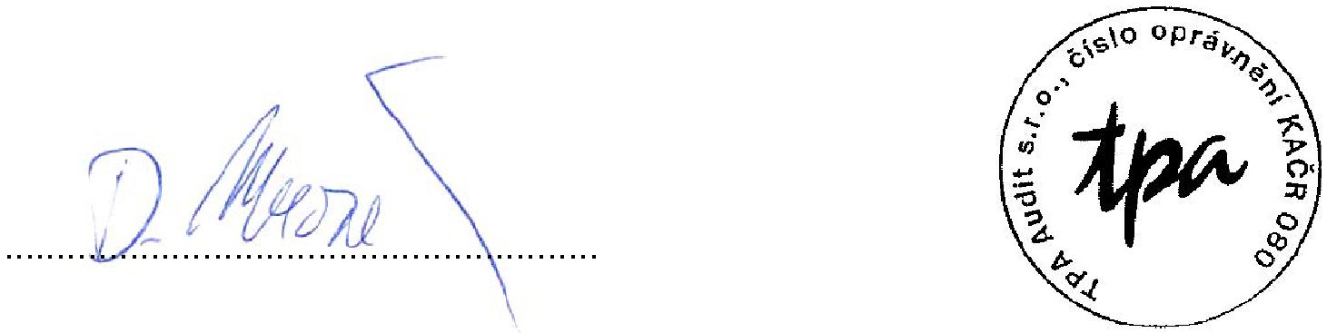
In Prague, on 30 April 2024

Auditor:
Ing. David Mrozek TPA Audit s.r.o.
Authorisation Number of the Chamber Antala Staška 2027/79, Prague 4
of Auditors of the Czech Republic: 2309 Authorisation Number of the Chamber
of Auditors of the Czech Republic: 080

COMPANY PROFILE
Company´s Basic Data
ZDR Investments SICAV a. s.
Company ID: 064 21 091
Headquarters: Jungmannova 750/34, Nové Město, 110 00 Prague 1
Company entered in the Commercial Register kept by the Municipal Court in Prague, Section B, File no. 22826 (hereinafter referred to as the "Company")

The Company was established by a founding legal act in accordance with the relevant provisions of Section 125 of Act No. 89/2012 Coll., the Civil Code, as amended, and. Section 2(2) of Act No. 90/2012 Coll., on Business Corporations and Cooperatives, as amended by the adoption of the Articles of incorporation on 29 May 2017.

The Company was established by entry in the Commercial Register on 12 September 2017. The Company was entered into the list of investment funds maintained by the Czech National Bank pursuant to Section 597(a) of Act No. 240/2013 Coll., on Investment Companies and Investment Funds, as amended (hereinafter referred to as "ICIFA") on 20 July 2017.

Subject of business

The subject of the Company's business is the activity of an investment fund of qualified investors within the meaning of the ICIFA.

Company LEI

3157007F21XKI9OE9C36

Share capital

The amount of the paid-up subscribed capital is CZK 60.00.

Securities issued by the Company

Security type | Founder's shares (Ordinary)
Form | Registered shares
Type | Documentary
Number of issued shares as of 31 December 2023 | 60
Share in the subscribed share capital | 100 %

Limitations on transferability

The transferability of the shares to third parties is subject to the consent of the Company's statutory body, which will be granted on condition that the acquiring investor is a qualified investor within the meaning of the provisions of Section 272 ICIFA.

Statutory bodies of the Company

Sole Member of the Board of Trustees
CODYA Investment Company, a.s.,
Company ID: 068 76 897,
Headquarters: Poňava 135/50, 664 31 Lelekovice, Company entered in the Commercial Register kept by the Regional Court in Brno, Section B, File no. 7923
Date of inauguration to function: 01 November 2019

Authorised Agent: Ing. Robert Hlava (Date of inauguration to function: 18 January 2021)
Bc. Martin Pšaidl (Date of inauguration to function: 30 August 2022)
Ing. Michal Sedlák, MBA (Date of inauguration to function: 30 August 2022)

Delegation of certain activities

The statutory body of the Company has entrusted the internal audit to ASIG CONSULT, s.r.o., Company ID: 05800668, with its registered offices at Varnsdorfská 330/19, 190 00 Prague 9, company entered in the Commercial Register kept by the Municipal Court in Prague, Section C, File no. 270999.

Investments in the Company or the Company's sub-funds are also offered through authorised agents.

In addition, an agreement has been executed on entrusting another entity with the performance of individual activities, including the investment fund management, with Advisory 4 Funds s.r.o., Company ID: 24220477, with its registered offices at Jungmannova 750/34, Nové Město, 110 00 Prague 1, company entered in the Commercial Register kept by the Municipal Court in Prague, in Section C, under File no. 189899 and the company Z/C/H Legal v.o.s., law firm, Company ID: 17877130, with its registered offices at Národní 973/41, Staré Město, 110 00 Prague 1, company entered in the Commercial Register kept by the Municipal Court in Prague, in Section A, File no. 80113 (the company was established by a spin-off, when part of the assets of the split company, Z/C/H Legal v.o.s., law firm, Company ID: 272 22 861, with registered offices at Národní 973/41, Staré Město, 110 00 Prague 1, was passed onto it).

REPORT ON THE COMPANY'S BUSINESS ACTIVITIES AND THE STATE OF ITS ASSETS FOR THE YEAR 2023

Company´s Basic Data

ZDR Investments SICAV a.s. (hereinafter referred to as the "Company") is a legal entity seated in the Czech Republic, authorised to collect funds or things valuable at money from multiple qualified investors by issuing participatory securities of its sub-funds or by making qualified investors its shareholders, and to make joint investments of the collected funds or things valuable at money on the basis of a determined investment strategy, generally based on the principle of risk spreading, for the benefit of these qualified investors, and to further manage these assets. The company is a qualified investors´fund and was established by entry in the Commercial Register on 12 September 2017. The Company was entered into the list of investment funds maintained by the Czech National Bank pursuant to Section 597(a) of the ICIFA on 20 July 2017.

The Company is authorised to manage and administer itself through its individual statutory body, which is the legal entity authorised to manage the Company. Hence, the Company is managed by CODYA Investment Company, a.s. (hereinafter referred to as the "Statutory Body").

The Company may create sub-funds in accordance with its Articles of Association. The Company has created a sub-fund, the ZDR Real Estate Sub-Fund.

Company Business Activities

The Company's objective is to create individual sub-funds through which the Company seeks to capitalise investors' funds. The Company's investment objective in 2023 was to collect funds or things valuable at money from qualified investors and invest them in accordance with the defined investment strategy of the created sub-fund. The Company as such does not engage in investment activities.

The Company's economic earnings were audited by TPA Audit s.r.o., company ID 602 03 480, with registered offices at Antala Staška 2027/79, Krč, 140 00 Prague 4. The auditor is registered with the Chamber of Auditors of the Czech Republic under No. 080.

Company's financial performance in 2023

A true and fair view of the Company´s performance is given by the regular Financial Statements for the period from 1 January 2023 to 31 December 2023 (hereinafter referred to as the "Fiscal Year") and the Notes to Financial Statements, which form an integral part of this Annual Report.

Company's Asset Status

Assets
As of 31 December 2023, the Company recorded assets in total worth CZK 60.00.

Liabilities
Total liabilities of the Company as of 31 December 2023 amount to CZK 60.00.
Outlook for 2024

The Company will continue to exist without engagement in any activities. The Company's business solely consists in holding the Company's authorised share capital for which the Company has issued founder shares. The financial statements are prepared separately for the Company and for each sub-fund. The outlooks for sub-funds´ activities in 2024 are described in their separate annual reports.

In Brno, on 30 April 2024

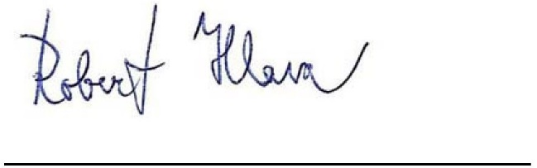
ZDR Investments SICAV a.s.
Ing. Robert Hlava
Authorised Agent of the Sole Member of the Board of Trustees
CODYA Investment Company, a.s.

REPORT ON RELATIONS FOR FINANCIAL YEAR 2023

Control data

ZDR Investments SICAV a. s., Company ID: 06421091, with its registered offices at Jungmannova 750/34, Nové Město, 110 00 Prague 1, company entered in the Commercial Register kept by the Municipal Court in Prague, in Section B, under File no. 22826 (hereinafter referred to as the "Company") is an entity controlled by the following natural persons:

JUDr. Zdeněk Prázdný, born 18 April 1960, permanently residing at Ohradní 1353/33, Michle, 140 00 Prague 4, who subscribed 21 founder shares of the Company, which represented a 35 % share in the registered share capital of the Company,

Roman Latuske, born 24 September 1973, permanently residing at V Kopci 320, Chlomek, 252 06 Petrov, who subscribed 18 founder shares of the Company, which represented a 30 % share in the registered share capital of the Company,

Mgr. Radek Hladký, born 16 April 1976, permanently residing at Šlechtitelská 992, Klánovice, 190 14 Prague 9, who subscribed 21 founder shares of the Company, which represented a 35 % share in the registered share capital of the Company,

(hereinafter referred to as the "Controlling Persons"). The Company is a joint-stock company with variable share capital and is managed through its Statutory Body. The Company's share capital is equal to its fund capital. The amount of the fund capital is variable. The amount deposited by subscription of the founder shares (registered share capital) is entered in the Commercial Register as the Company's share capital. 100 % of the Company's founder shares were subscribed by the Controlling Persons.

The Company is independent in relation to the entities controlled by the Controlling Persons, as its business is to collect funds or things valuable at money from multiple qualified investors by issuing participatory securities or by making qualified investors its partners and to make joint investments of the collected funds or things valuable at money on the basis of a determined investment strategy, generally based on the principle of risk spreading, for the benefit of these qualified investors, and to further manage these assets.

Structure of relations between entities

The structure of relationships between the Controlling Persons and the Company and between the Company and entities controlled by one of the Controlling Persons is as follows:

Judr. Zdeněk Prázdný
35 %
Roman Latuske
30 %
Mgr. Radek Hladký
35 %

ZDR Investments SICAV a.s.

Entities outside the Company controlled by the Controlling Persons

There are no entities other than the Company controlled by the Controlling Persons.

Overview of actions

In 2023, no actions were taken at the instigation of or in the interest of the Controlling Persons or entities controlled by them involving assets exceeding 10 % of the Company's equity.

Overview of contracts

There are no contracts between the Company and the Controlling Persons.

Assessment of whether the Company has suffered damage and the damage compensation

The Company did not suffer any damage originating from the relationship with the Controlling Persons or in relation to any entities controlled by the Controlling Persons.

Advantages and disadvantages arising from relationships

No material advantages or disadvantages arise from the relationships between the Controlling Persons and the Company and between the Company and entities controlled by the Controlling Persons. There are no risks to the Company arising from these relationships.

The business governance and management of the Company's activities are vested in its Statutory Body, the Board of Trustees, whose sole member is the Company's manager. The statutory Body implements resolutions adopted by the General Meeting. The Statutory Body is not bound by shareholders´ instructions in relation to individual business transactions, manages the Company with professional care and conducts its business properly and prudently. To this end, the Statutory Body has established, maintains and applies a management and control system.

Controlling Persons have the possibility to exercise their shareholding rights in relation to the Company within the scope of powers of the General Meeting.

Statement of the Statutory Body

The Statutory Body hereby declares that it has prepared this Report on Relations on the basis of available information on the relationships between the Company and the Controlling Persons and between the Company and entities controlled by the Controlling Persons from public sources or from other persons or entities. The Statutory Body declares that it is not aware of any facts which should form part of the Company's Report on Relations and which are not set out in this report.
The Statutory Body declares that it has drawn up this report with due care and that the information given in this report is correct and complete.

In Brno, on 21 March 2024
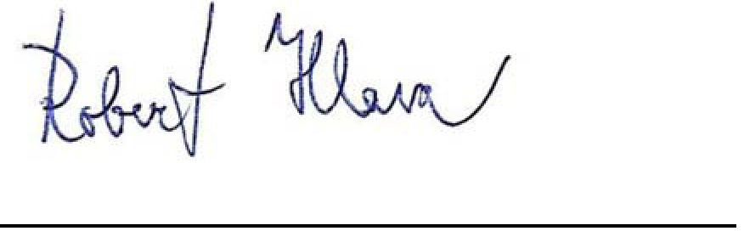
ZDR Investments SICAV a.s.
Ing. Robert Hlava
Authorised Agent of the Sole Member of the Board of Trustees
CODYA Investment Company, a.s.

SPECIAL TERMS OF THE ANNUAL REPORT
ZDR Investments SICAV a.s. (hereinafter referred to as the "Company") in accordance with the relevant provisions of Sections 291(1) and (3), 234(1)(a), (b) and (j) and 234(2), (6) and (8) of Act No. 240/2013 Coll., on Investment Companies and Investment Funds, as amended (hereinafter referred to as the "ICIFA"), Articles 103 to 107 of Commission Delegated Regulation (EU) No. 231/2013, (hereinafter referred to as the "Regulation"), Decree No. 244/2013 Coll, on Detailed adjustment of certain rules of the ICIF Act, as amended (hereinafter referred to as the “Decree”), and Section 21 (2) of Act no. 563/1991 Coll., on Accounting, as amended (hereinafter referred to as the "AA”), gives the following Special Terms of Annual Report. This Annual Report also includes Financial Statements, Independent Auditor's Report and Report on Relations. This report does not describe the Company´s individual sub-fund portfolio compositions, which are described in the sub-funds' separate annual reports.

Company's Activities in 2023
During 2023, the Company collected funds from qualified investors to the Company's sub-fund. The Company did not carry out any other activity.

Information about Events Occurring after Balance Sheet Date that are Material to the Purpose of Annual Report
There were no significant events after the balance sheet date.

Information on the Expected Development of the Company's Activities
The Company will continue to exist without engagement in any activities in 2024. The Company concluded that the above should not have a material effect on the going concern assumption.

Information on Research and Development Activities

The Company is not active in research and development.

Information on the Acquisition of Own Shares or Interests

The Company has not acquired any of its own shares or interests.

Information on Environmental Protection Activities and Labour Relations (Section 21(2)(f) of the AA)
The Company is not active in the field of environmental protection nor is it active in the field of labour relations.

Information on whether the Company has a Branch or other Part of Business Establishment Abroad (Section 21(2)(f) of the AA)
The Company does not have any branches abroad.

Development of Share Value in the Relevant Period in Graphical Format (Section 291(3) of the ICIFA in Conjunction with Annex 2(f) of the Decree
The Company does not engage in investment activities. The development of the value of the Investment Shares is shown in the sub-fund's Annual Report.

Details of the Activities of the Company´s Managing Entity in Relation to the Company's Assets in the Current Financial Year (Section 291(1) of the ICIFA in Conjunction with Section 234(1)(b) of the ICIFA and Article 105 of the Regulation)
During the financial year, the Manager carried out standard activities in relation to the Company in accordance with the Company's Articles of Incorporation. In terms of investments, no acquisition agreements were concluded during the financial year. A summary of the Company's activities, portfolio, results, material changes in data, including a review of the Company's activities and results and a description of the risks and investment or economic uncertainties that the Company may face, including key financial and non-financial performance indicators relating to the Company, to the extent necessary to understand the Company's investment activities or results, is provided in the Sub-Fund's Annual Report.

Identification details of each person performing asset management (Asset Manager) or external manager of the Company during the Relevant Period and the period during which he/she performed this activity, including a brief description of his/her experience and knowledge (Section 291(3) of the ICIFA in conjunction with Annex 2(a) of the Decree)
Name and surname: Ing. Michal Sedlák, MBA
Other identification data: born 17 March 1968
Performance as Asset Management Manager for the Company: since 1 October 2021, continuing
Knowledge and experience as Asset Manager: university graduate with degree in economics Since 1 April 2019, he has been working at CODYA investiční společnost, a.s., first as Head of Analysis in the Portfolio Management Department and since 1 October 2021 as Director of the Portfolio Management Department and member of the Board of Trustees. In his previous positions at Komerční banka a.s., Raiffeisenbank a.s. and Československá obchodní banka a.s., he was responsible for the bank's portfolio management, analysis and financing.

Identification details of the Company´s depositary during the Relevant Period and the period for which the depositary was acting as such (Section 291(3) of the ICIFA in conjunction with Annex 2(b) of the Decree)
Name: Česká spořitelna, a.s.
Company ID: 45244782
Headquarters: Olbrachtova 1929/62, post code 140 00, Prague 4
Depositary´s activities for the Company: the whole Financial Year
Identification details of each person entrusted with the custody or guardianship of the Company´s assets, if more than 1 % of the value of the Company's assets is held by such person (Section 291(3) of the ICIFA in conjunction with Annex 2(c) of the Decree
No such person was appointed by the Depositary in the course of the Financial Year.
Identification data of each person authorised to provide investment services who performed the activity of the Principal Support Agent in relation to the Company's assets during the relevant period and the period of time for which he/she performed this activity (Section291(3) of the ICIFA in conjunction with Annex 2(d) of the Decree)
During the Financial Year, the Company did not use any services of a Principal Support Agent.
Identification of assets with the value exceeding 1 % of the value of the Company's assets as of the date on which the valuation used for the purposes of this report was carried out, indicating the total cost and fair value at the end of the relevant period (Section 291(3) of the ICIFA in conjunction with Annex 2(e) of the Decree
The purpose of the Company existence is solely to ensure the prerequisites for the performance of the sub-fund's activities. All information regarding the Sub-Fund's assets is included in the Sub-Fund's Annual Report.
Litigations or arbitrations relating to disputes concerning the property or claims of the owners of securities or book-entry securities issued by the Company, if the value of the subject matter of the dispute exceeds 5 % of the value of the Company's assets in the relevant period, including details of any governmental, court or arbitration proceedings during the financial year which may have had, or recently have had a significant effect on the financial position or profitability of the Company or its group, or a statement that no such proceedings exist ( section 291(3) of the ICIFA in conjunction with Annex 2(g) of the Decree
During the financial year, the Company was not a party to any litigation or arbitration involving property or claims of owners of securities or book-entry securities issued by the Company where the value of the subject matter of the litigation would exceed 5 % of the value of the Company's assets during the financial year.

The Company was not involved in any administrative, court or arbitration proceedings during the financial year which may have had or had a material effect on the financial position or profitability of the Company in the past.
The value of all profit shares paid out per investment share (Section 291(3) of the ICIFA in conjunction with Annex 2(h) of the Decree)
The Company does not issue investment shares other than to its sub-fund. This information is therefore included in the sub-fund's annual report.

Data on the actual fee paid to the Company Manager for the Sub-Fund management activities, distinguishing between data on the fee paid for the performance of the activities of the Depositary, Administrator, Principal Support Agent and Auditor, and data on other costs or taxes (Section 291(3) of the ICIFA in conjunction with Annex 2(i) of the Decree)
This information is contained in the sub-fund's annual report.
Data relating to the promotion of environmental or social performance and sustainable investments pursuant to Article 11 of Regulation (EU) 2019/2088 of the European Parliament and of the Council and data pursuant to Articles 5 to 7 of Regulation (EU) 2020/852 of the European Parliament and of the Council (Section 291(1) of the ICIFA in conjunction with Section 234(1)(j) of the ICIFA)
The underlying investments of the Company do not take into account the EU criteria for environmentally sustainable economic activities.
Details of material changes to the information set out in the Company's Articles of Incorporation that occurred during the Financial Year (Section 291(1) of the ICIFA in conjunction with Section 234(2)(a) of the ICIFA and Article 106 of the Regulation)
There were no material changes to the Company's Articles of Incorporation during the financial year.
Details of salaries, wages, remuneration and similar income of employees and managers that may be considered as remuneration paid by the Company Manager to its employees or managers during the Financial Year, broken down into fixed and variable components, details of the number of employees and managers of the Company Manager and details of any capital appreciation remuneration paid by the Company or its Manager (Section 291(1) of the ICIFA in conjunction with Section 234(2)(b) of the ICIFA and Article 107 of the Regulation)
The officers of the Company's statutory body (including the Portfolio Manager) and the authorised representatives of the statutory body are remunerated by the Statutory Body Member in accordance with its internal remuneration policy, developed with regard to the requirements of the AIFMR. These persons are not remunerated by the Company.

The Company's Statutory Body has established a system for remuneration of its employees, including all executives, such that remuneration consists of a compulsory component (salary) and a non-claimable component (performance-related remuneration). The non-claimable component of the remuneration is paid upon fulfilment of pre-defined conditions, which are usually based on the economic earnings achieved by the Company's Statutory Body and the performance evaluation of the individual employee.

The Statutory Body of the Company is obliged to disclose information on the remuneration of its employees. Due to the fact that the Company's Statutory Body manages more than one investment fund, the figures below are a proportionate part of the total remuneration paid by the Company's Statutory Body to its employees.

Specific information is contained in the sub-fund's annual report.
Details of salaries, remuneration and similar income of employees or managers that may be considered as remuneration paid by the Company Manager to those of its employees or managers whose activities have a material impact on the risk profile of the Company (Section 291(1) of the ICIFA in conjunction with Section 234(2)(c) of the ICIFA and Article 107 of the Regulation)
The Company's Statutory Body applies specific remuneration policies and procedures in relation to employees who have a significant influence on the risks to which the Company's Statutory Body or the Company itself may be exposed. These remuneration policies and practices promote sound and effective risk management and avoid conflicts of interest.

Specific information is contained in the sub-fund's annual report.

In Brno, on 30 April 2024
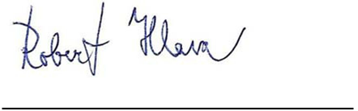
ZDR Investments SICAV a.s.
Ing. Robert Hlava
Authorised Agent of the Sole Member of the Board of Trustees
CODYA Investment Company, a.s.

ZDR INVESTMENTS SICAV A.S.
FINANCIAL STATEMENTS AS
OF 31 DECEMBER 2023

Table of Contents
1. Balance sheet 3
2. Profit and loss sheet for the period ending 31st december 2023 4
3. Statement of changes in equity for the period ending 31st december 2023 5
4. General information 7
4.1. Fund formation and characteristics 7
4.2. Basis for financial statements preparation 8
5. Accounting procedures applied 9
5.1. The moment of accounting case realisation 9
5.2. Financial instruments 9
5.3. Fair value measurement 9
5.4. The fund's share capital 10
5.5. Related parties 10
5.6. Subsequent events 11
6. Figures for balance sheet and profit and loss account items 11
6.1. Other assets 11
6.2. Share capital 11
6.3. Capital funds 11
6.4. Retained earnings or uncovered loss of previous periods 12
6.5. Values handed over for management 12
7. Mutual relations 12
8. Fair value of assets and liabilities 12
9. Overview of financial instruments as of 31 december 2023: 12
10. Risks 12
10.1. Currency risk 12
10.2. Credit risk 13
10.3. Liquidity risk 13
11. Subsequent events 13

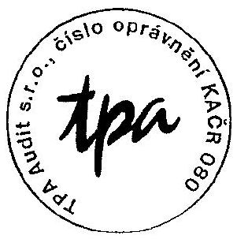

BALANCE SHEET
In CZK thousands

Number | Assets | Note | Balance as of 31 December 2023 | Balance as of 31 December 2022
11. | Other assets | 6.1 | 0 | 0
 | Assets total |  | 0 | 0

 | Liabilities | Note | Balance as of 31 December 2023 | Balance as of 31 December 2022
12. | Capital funds | 6.3 | 0 | 0
14. | Retained earnings or uncovered loss of previous periods | 6.4 | 0 | 0
 | Equity total |  | 0 | 0
 | Liabilities total |  | 0 | 0

Number | Off-balance sheet items | Note | Balance as of 31 December 2023 | Balance as of 31 December 2022
8. | Values handed over for management | 6.5 | 0 | 0

PROFIT AND LOSS SHEET FOR THE PERIOD ENDING 31st DECEMBER 2023
No income or costs were recognised in the current period or the previous comparable period.

STATEMENT OF CHANGES IN EQUITY FOR THE PERIOD ENDING 31st DECEMBER 2023
In CZK thousands

 | Capital funds | Undivided profit (loss) | Total
Balance as of 31 December 2022 | 0 | 0 | 0
Liability capitalisation | 0 | 0 | 0
Repayment of losses from previous years from capital funds | 0 | 0 | 0
Balance as of 31 December 2023 | 0 | 0 | 0

NOTES TO FINANCIAL STATEMENTS FOR THE YEAR ENDING 31st DECEMBER 2023

GENERAL INFORMATION

FUND FORMATION AND CHARACTERISTICS
ZDR Investments SICAV, a.s., with registered offices at Jungmannova 750/34, Nové Město, 110 00 Prague 1, company ID 064 21 091 (hereinafter referred to as the "Fund") was established on 12 September 2017 by the Fund entry in the Commercial Register. On 20 July 2017, the Fund was entered in the list of investment funds with legal entity status maintained by the Czech National Bank.

The Fund is subject to the regulatory requirements of Act No. 240/2013 Coll., on Investment Companies and Funds, as amended (hereinafter referred to as the "ICIFA").

The Fund is a qualified investors' fund which, within the meaning of Section 95(1) of the ICIFA, collects cash or things valuable at money from multiple qualified investors by issuing participatory securities, realises joint investments of the collected cash or things valuable at money on the basis of a designated investment strategy for the benefit of these qualified investors, and further manages these assets.

The Fund is neither a managing nor a subordinated fund and is established for an indefinite period of time. In accordance with the Articles, the Fund creates sub-funds. At the date of its incorporation, the Fund created a sub-fund called ZDR, Real Estate Sub-Fund (the "Sub-Fund"). The sub-fund is a qualified investors´ fund within the meaning of Section 95(1) of the ICIFA.

The amount of the paid-up subscribed capital is CZK 60.00 (until 24 November 2021 the amount of the paid-up subscribed capital was CZK 30,-). He amount of the recorded share capital corresponds to the amount of the subscribed founder shares. The Fund´s share capital is equal to its fund capital.

The depository of the Fund, as of 31 December 2023 is:
Česká spořitelna, a.s., company ID: 452 44 782, with registered offices at Olbrachtova 1929/62, Prague 4, post code 140 00.

The statutory body of the Fund, as of 31 December 2023 is:
CODYA Investment Company, a.s., company ID 068 76 897, with registered offices at Poňava 135/50, 664 31 Lelekovice, represented in the performance of its duties by Ing. Robert Hlava, Bc. Martin Pšaidl and Ing. Michal Sedlák, MBA.

The Fund's property portfolio is managed by the Fund's manager, CODYA Investment Company, a.s. (hereinafter referred to as the "Company"). The Company accounts for the status and movement of the Fund's assets separately from its own assets and assets in other funds it manages.

The Fund has no employees. The Fund's property portfolio is managed by the Fund's manager, CODYA Investment Company, a.s.

BASIS FOR FINANCIAL STATEMENTS PREPARATION
The Fund´s financial statements are prepared in accordance with Act No. 563/1991 Coll., on Accounting, as amended, and Decree No. 501/2002 Coll., implementing certain provisions of Act No. 563/1991 Coll., on Accounting, as amended, for accounting units that are banks and other financial institutions (hereinafter referred to as the "Decree").

In accordance with Section 4a(1) of the Decree, the Fund reports, measures and discloses in the Notes to Financial Statements information on financial instruments in accordance with the International Accounting Standards as modified by the directly applicable European Union regulations on the application of IAS.

The Financial Statements, including Balance Sheet, Profit and Loss Sheet, Statement of Changes in Equity and related Notes, are prepared in accordance with the Accounting Act, decrees issued by the Ministry of Finance of the Czech Republic and the Czech Accounting Standards for Financial Institutions. They are prepared on the basis of the historic acquisition price principle, modified by measuring financial instruments at fair value.

The financial statements comply with the general accounting principles, in particular the principle of time and material accounting, the principle of prudence and the going concern assumption.

The preparation of Financial Statements requires that the Fund makes estimates affecting the reported asset and liability and contingent asset and liability values at the balance sheet date and the profit and loss reporting date. These estimates are based on information available as of the balance sheet date and may differ from actual results.

Amounts in the Financial Statements are rounded to thousands of Czech crowns (CZK thousands), unless stated otherwise, and are not consolidated.

The Fund´s Financial Statements are prepared for the financial year starting 1st January 2023 and ending 31st December 2023. The comparable prior period is in the accounting period of 1 January 2022 – 31 December 2022.

The Fund´s Financial Statements are audited in accordance with Section 187 of the ISIFA.

The Company has assessed the presumption of the Fund's continued existence and has concluded that, in the absence of adverse factors, the presumption of the Fund's continued existence, i.e. that the Fund is able to continue its activities in the future, is not doubtful.

The Financial Statements as of 31 December 2023 have therefore been prepared on the basis of the assumption that the Fund will be able to continue its activities as a going concern.

At the time of publication of these Financial Statements, the Company had not experienced any impact on the Fund's operations, however, the situation is constantly changing and therefore it is not possible to predict future impacts of the geopolitical situation on the Sub-Fund's operations. The Company will continue to monitor any potential impact and take all possible steps to mitigate any negative effects on the Fund.

ACCOUNTING PROCEDURES APPLIED

THE MOMENT OF ACCOUNTING CASE REALISATION
Financial assets and liabilities are recognised when the Fund becomes a party to the respective operation giving rise to them. The Fund derecognises a financial asset or its part from its balance sheet if it loses control of the contractual rights to that financial asset or its part. The Fund loses this control if it exercises rights to the benefits defined in the contract, if those rights cease or are waived by the Sub-Fund.

A financial liability or its part is dissolved when the obligation defined in the respective contract is discharged, cancelled or expires and the accounting unit no longer recognises the financial liability or its part in the balance sheet. The difference between the carrying amount of a liability, or part thereof, that has been dissolved or transferred to another entity, and the amount paid to meet that liability, is charged to cost or income.

FINANCIAL INSTRUMENTS
According to Section 4a of the Decree, from 1 January 2021 all financial instruments are subject to the rules under IFRS 9 Financial Instruments.
The Fund only uses the following category for the financial instrument valuation:
- Financial instruments at fair value through profit or loss (FVTPL).
Financial assets and financial liabilities are recognised in the balance sheet when the Fund becomes a party to the contractual provisions on the financial instruments.

Financial assets and liabilities are measured at fair value on initial recognition. The fair value of financial assets or financial liabilities not designated as “at fair value through profit or loss” shall be adjusted for transaction costs directly attributable to the acquisition or issue of the financial instrument. The Fund recognises the following items in the Balance Sheet:
- Other assets

FAIR VALUE MEASUREMENT
International Financial Reporting Standard IFRS 13 defines fair value as the price at which an asset could be sold or a liability transferred in a standard transaction between market players at a given date.

In practice, one or a combination of three valuation approaches is used to determine fair value:
- Market approach = uses prices and other relevant information obtained through market transactions involving identical or comparable (i.e. similar) assets, liabilities or a group of assets and liabilities such as an enterprise.
- Income approach = converts future amounts (e.g. cash flows or revenues and costs) to their present (discounted) value. The fair value measurement is determined based on the value indicated by current market expectations concerning these future amounts.
- Cost approach = takes into account the amount that would currently be required to replace the asset's output capacity (often called the normal replacement cost).
Fair value hierarchy

Only Level 3 inputs are used by the Fund to value its financial instruments.
- Level 3 inputs – Level 3 inputs are unobservable input quantities. This level includes all instruments for which valuation methods include inputs that are unobservable and these unobservable inputs have a significant impact on the measurement of the instrument. This level includes instruments that are valued on the basis of quoted prices for similar instruments for which significant unobservable adjustments or assumptions are required to reflect differences existing between the instruments.
Short-term assets and liabilities with a maturity of one year or less are measured at their nominal value, which is assumed to be comparable to fair value.

THE FUND'S SHARE CAPITAL
The Fund´s share capital is made up of a number of founder shares in documentary form, of registered share type, and are lump shares (without par value) issued to the founders of the Fund. The currency of the founder share issue price is CZK.
Individual founder shares of one shareholder may be replaced by a collective share. The Fund´s founder shares, in accordance with the relevant provisions of Section 159(2) of the ICIFA, can be traded neither on the European regulated market nor on any other public market. The founder shares, as registered securities, are held by the Fund shareholders, who are responsible for their safekeeping.

RELATED PARTIES
Related parties are defined in accordance with the related party disclosure as follows:
a) A person or a close family member of that person, if that person:
(i) controls or jointly controls the reporting entity; or
(ii) has a substantial interest or influence, direct or indirect; or
(iii) is a member of the key management of the entity or its parent

b) An entity is related to the reporting entity if any of the following conditions apply:
(i) the entity and the reporting entity are members of the same group, an associate or joint venture of another entity or a joint venture of a group.
(ii) Both entities are joint ventures of the same third party.
(iii) One entity is a joint venture of a third entity and the other entity is an associated undertaking of the third entity.
(iv) The entity is controlled or jointly controlled by the person specified under a) above, or such a person exercises substantial influence over the entity or is a member of the entity's key management body.

Significant transactions, balances and pricing methods for related party transactions are presented in the Related Party Relationships tables.

SUBSEQUENT EVENTS
The impact of events that occurred between the balance sheet date and the financial statements date is recognised in the financial statements if those events provide additional evidence of conditions that existed as of the balance sheet date.

Where significant events involving conditions that occurred after the balance sheet date happened between the balance sheet date and the financial statements date, the effects of those events are described in the Notes but are not recognised in the Financial Statements.

FIGURES FOR BALANCE SHEET AND PROFIT AND LOSS ACCOUNT ITEMS
Note

Items not quantified in the tables below showed no movements or balances.

OTHER ASSETS
CZK thousands | 31 December 2023 | 31 December 2022
 | Total | Total
Other assets | 0 | 0
Total | 0 | 0
Other assets consist of other operating receivables in the amount of CZK 60 (31 December 2022: CZK 60).

SHARE CAPITAL
CZK thousands |  | 31 December 2023 | 31 December 2022
(Documentary, registered) | Pcs | Total | Total
Founder shares | 60 | 0* | 0
Total |  | 0 | 0

*The founder shares are worth CZK 1 per share. As only 60 founder shares were issued with a total value of CZK 60.00, this amount was rounded down to CZK 0 thousand.

CAPITAL FUNDS
CZK thousands | 31 December 2023 | 31 December 2022
Capital funds | 0 | 0
Total | 0 | 0

RETAINED EARNINGS OR UNCOVERED LOSS OF PREVIOUS PERIODS
CZK thousands | 31 December 2023 | 31 December 2022
Retained earnings or uncovered loss of previous periods | 0 | 0
Total | 0 | 0

VALUES HANDED OVER FOR MANAGEMENT
The assets of the Fund totalling CZK 60 as of 31 December 2023 (31 December 2022: CZK 60) are managed by the Company.

MUTUAL RELATIONS
Receivables from related party | 31 December 2023 | 31 December 2022
ZDR, Real Estate Sub-Fund | 0 | 0
Total | 0 | 0

As of 31 December 2023, the Fund records a receivable from the Sub-Fund in the amount of CZK 60,- (31 December 2022: CZK 60).

FAIR VALUE OF ASSETS AND LIABILITIES
The receivable from the Sub-Fund in the amount of CZK 60 is valued at its nominal value, which is assumed to be comparable to its fair value.

The inputs for all assets are at level 3.

There were no transfers between levels 1, 2 and 3 during 2023.

OVERVIEW OF FINANCIAL INSTRUMENTS AS OF 31 DECEMBER 2023:
CZK thousands | As of 31 December 2023 | As of 31 December 2022
Assets | FVTPL is mandatory | FVTPL is mandatory
Other assets | 0 | 0
Total | 0 | 0

RISKS

CURRENCY RISK
The Fund does not carry out any transactions in foreign currencies. Hence the risk associated with exchange rate fluctuations does not exist. Exposure to currency risk is zero.
All assets of the Fund as of 31 December 2023 are in CZK.

CREDIT RISK
Credit risk is the risk arising from the inability or unwillingness of a counterparty to pay its contractual obligations, arising mainly from receivables from customers. Credit risk mainly arises from borrowings provided.
The financial assets consist entirely of the receivable from the Sub-Fund and the credit risk is assessed as low.

Geographical concentration of risks
All assets of the Fund are located in the Czech Republic.

LIQUIDITY RISK
Liquidity risk is the ability of the Fund to meet its maturing obligations. As of 31 December 2023, the Fund did not record any payables towards banks or non-bank entities.

SUBSEQUENT EVENTS
There were no other significant events occurring between the Balance Sheet date and the Financial Statements date that might affect the Financial Statements as of 31 December 2023.

Compilation date Statutory representative´s signature

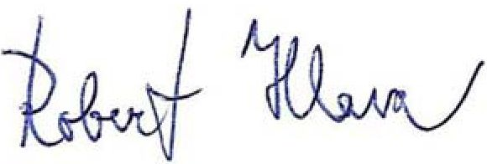
ZDR Investments SICAV a.s.
Ing. Robert Hlava
Authorised Agent of the Sole Member of the Board of Trustees of
30 April 2024 CODYA investiční společnost, a.s.

